Saint Stanislaus School |  | April 2021
Sun | Mon |  | Tue | Wed | Thu | Fri | Sat
 |  |  |  |  | 1  Easter Break Begins | 2  Good Friday | 3
4 Easter Sunday  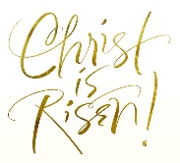 | 5 |  | 6 | 7 | 8 | 9 | 10
11  Tuition/Fees Due | 12  Classes Resume |  | 13 | 14  Mass | 15 | 16  Good Kids’ Activity | 17
18  MAP Testing Begins | 19 |  | 20 | 21  Mass | 22  Authors’ Tea | 23 | 24  First Reconciliation
25 | 26 |  | 27 | 28  Mass | 29  Progress Reports | 30 | Did you re-register for next year?

